**Tasks 4: Subquery and its types**

**1. Calculate the Average Ticket Price for Events in Each Venue Using a Subquery.**

SELECT v.venue_name,

(SELECT AVG(e.ticket_price)

FROM Event e

WHERE e.venue_id = v.venue_id) AS avg_ticket_price

FROM Venue v;

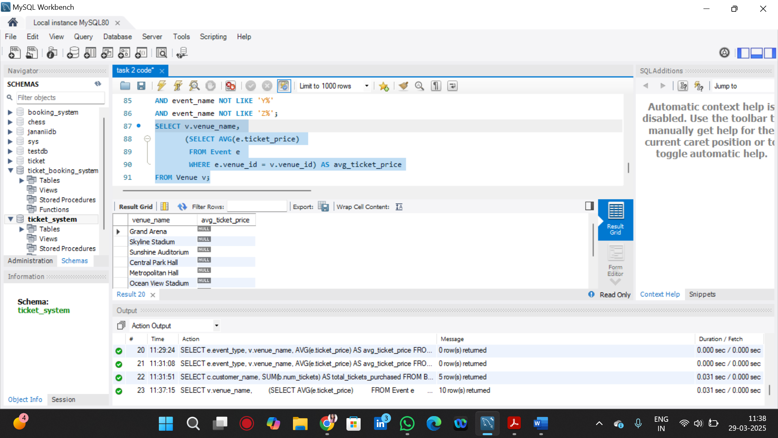

2. Find Events with More Than 50% of Tickets Sold using subquery.

SELECT event_name, total_seats, available_seats, (total_seats - available_seats) AS tickets_sold

FROM Event

WHERE (total_seats - available_seats) > (total_seats * 0.5);

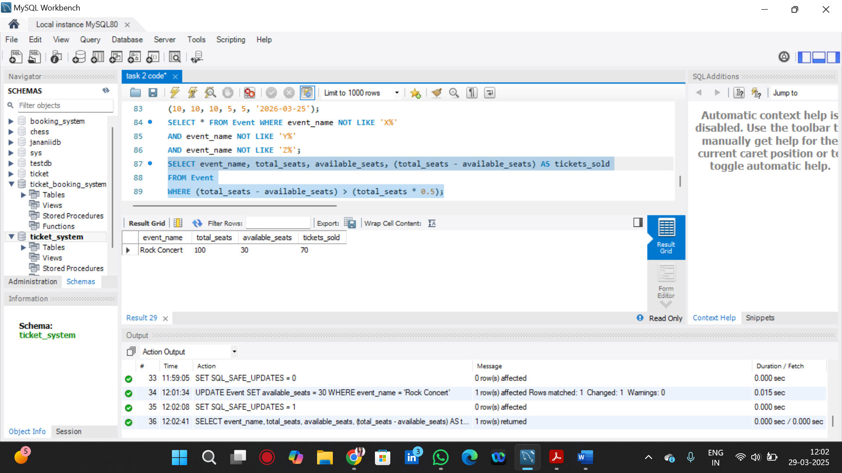

3. Calculate the Total Number of Tickets Sold for Each Event.

SELECT event_name,

(SELECT SUM(num_tickets)

FROM Booking b

WHERE b.event_id = e.event_id) AS total_tickets_sold

FROM Event e;

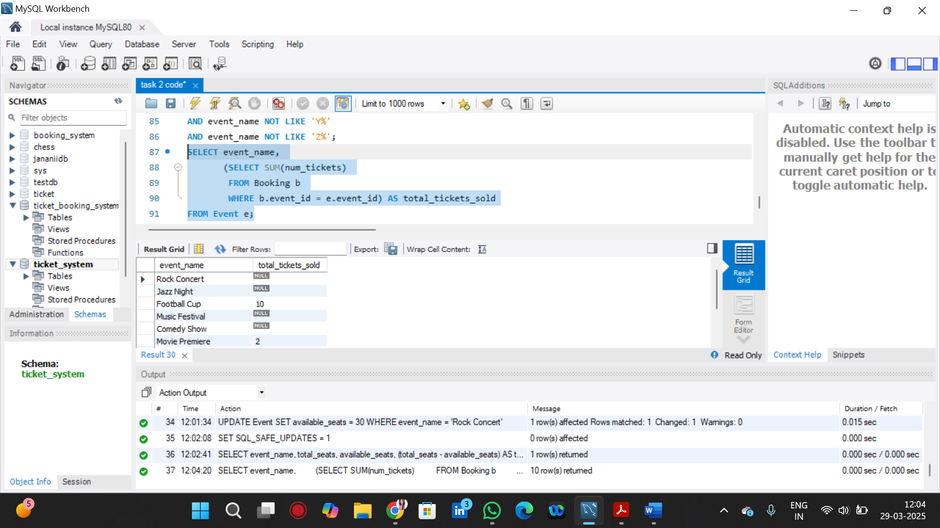

4. Find Users Who Have Not Booked Any Tickets Using a NOT EXISTS Subquery.

SELECT customer_name

FROM Customer c

WHERE NOT EXISTS (SELECT 1 FROM Booking b WHERE b.customer_id = c.customer_id);

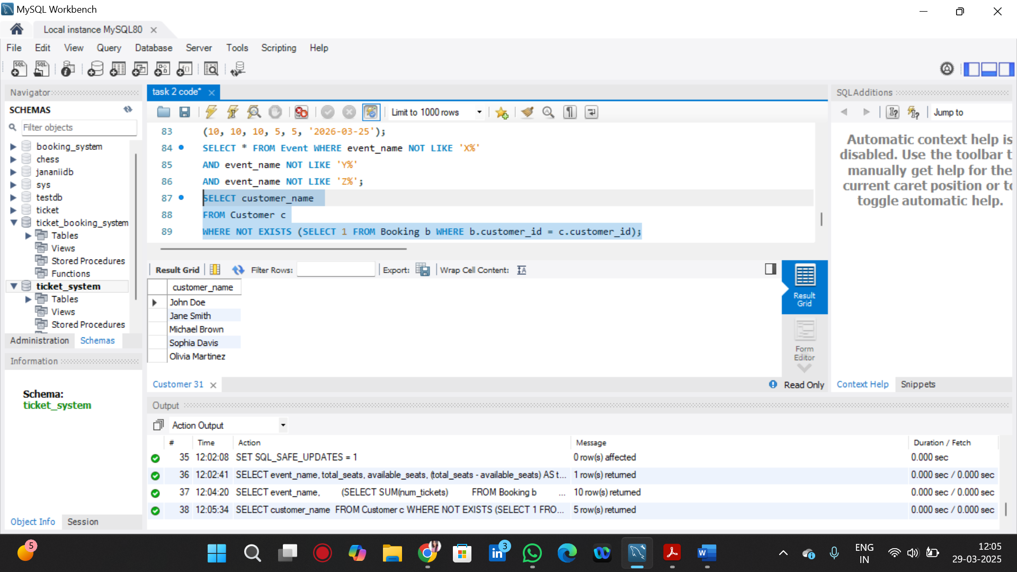

5. List Events with No Ticket Sales Using a NOT IN Subquery

SELECT event_name

FROM Event

WHERE event_id NOT IN (SELECT DISTINCT event_id FROM Booking);

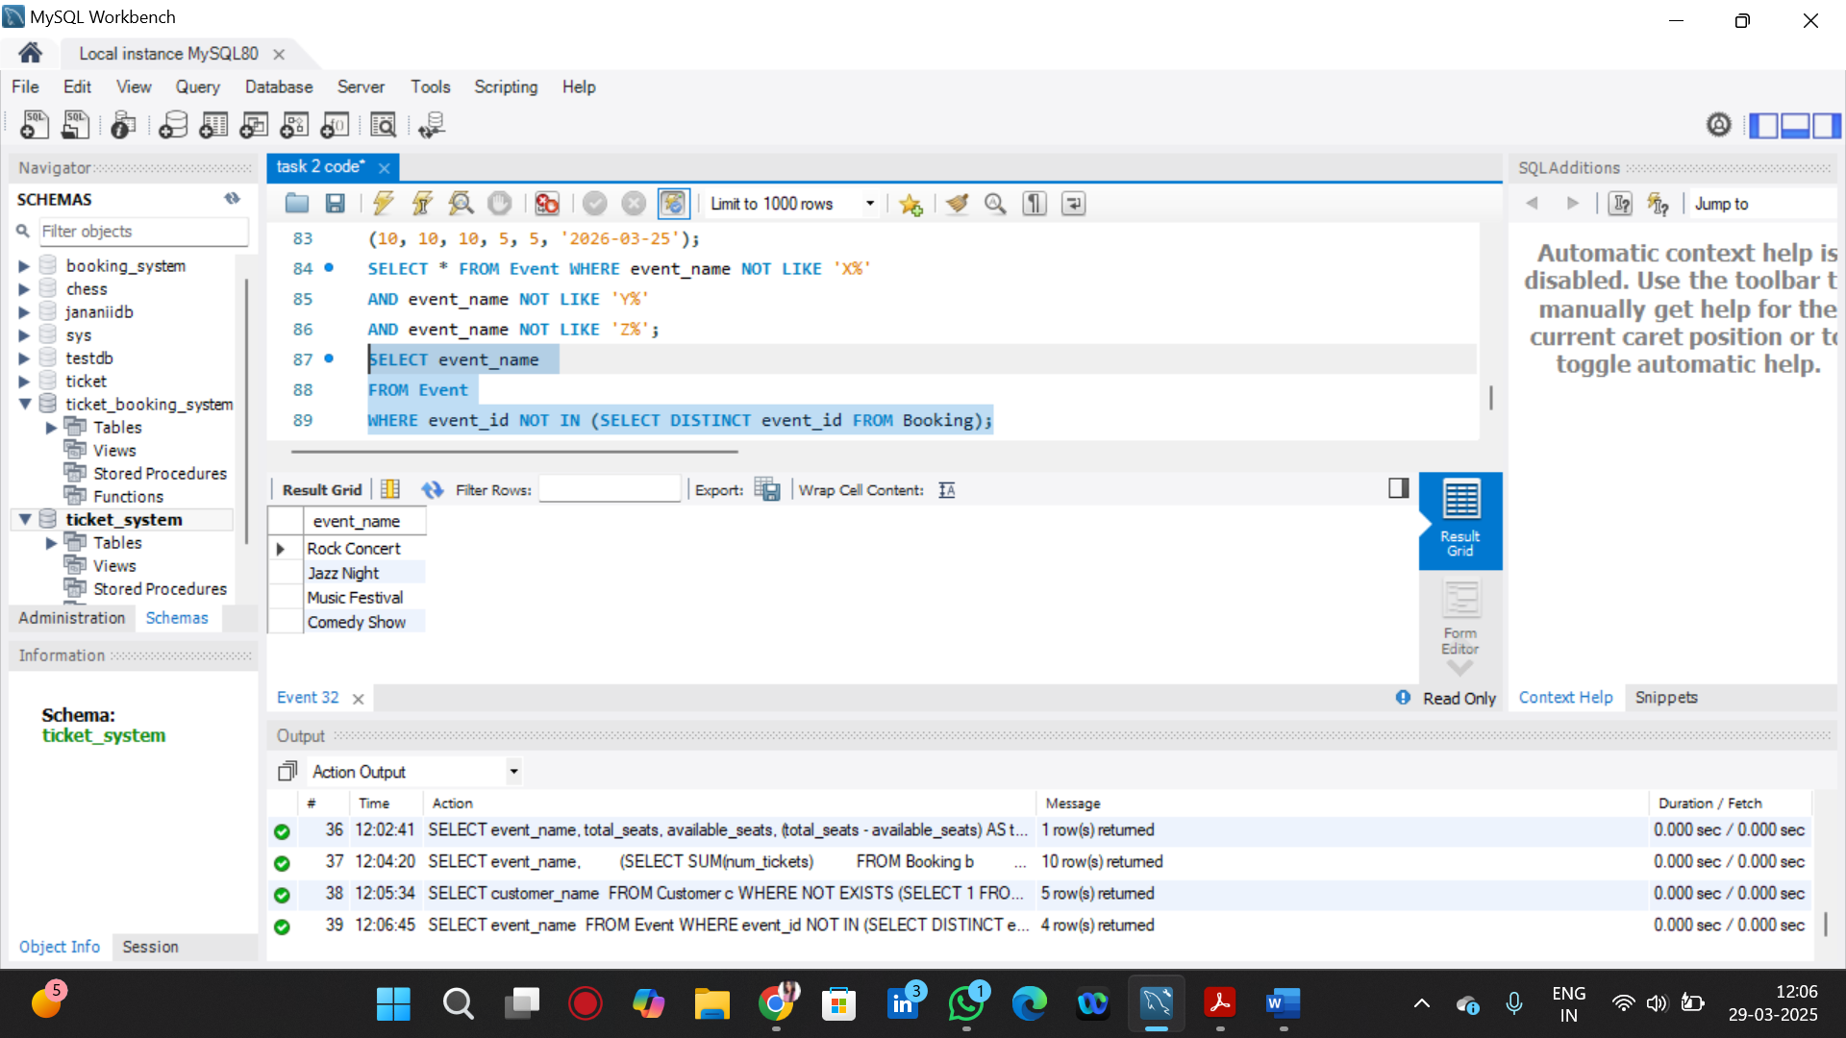

6. Calculate the Total Number of Tickets Sold for Each Event Type Using a Subquery in the FROM Clause.

SELECT event_type, SUM(tickets_sold) AS total_tickets_sold

FROM (

SELECT event_type, (total_seats - available_seats) AS tickets_sold

FROM Event

) AS TicketCounts

GROUP BY event_type;

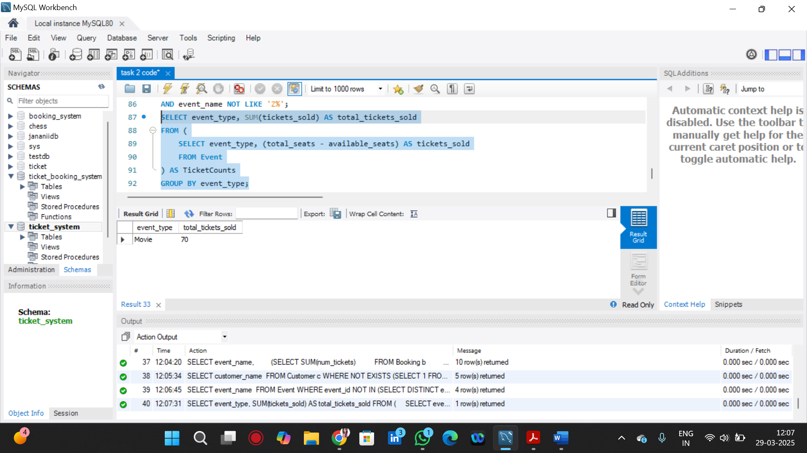

7. Find Events with Ticket Prices Higher Than the Average Ticket Price Using a Subquery in the WHERE Clause.

SELECT event_name, ticket_price

FROM Event

WHERE ticket_price > (SELECT AVG(ticket_price) FROM Event);

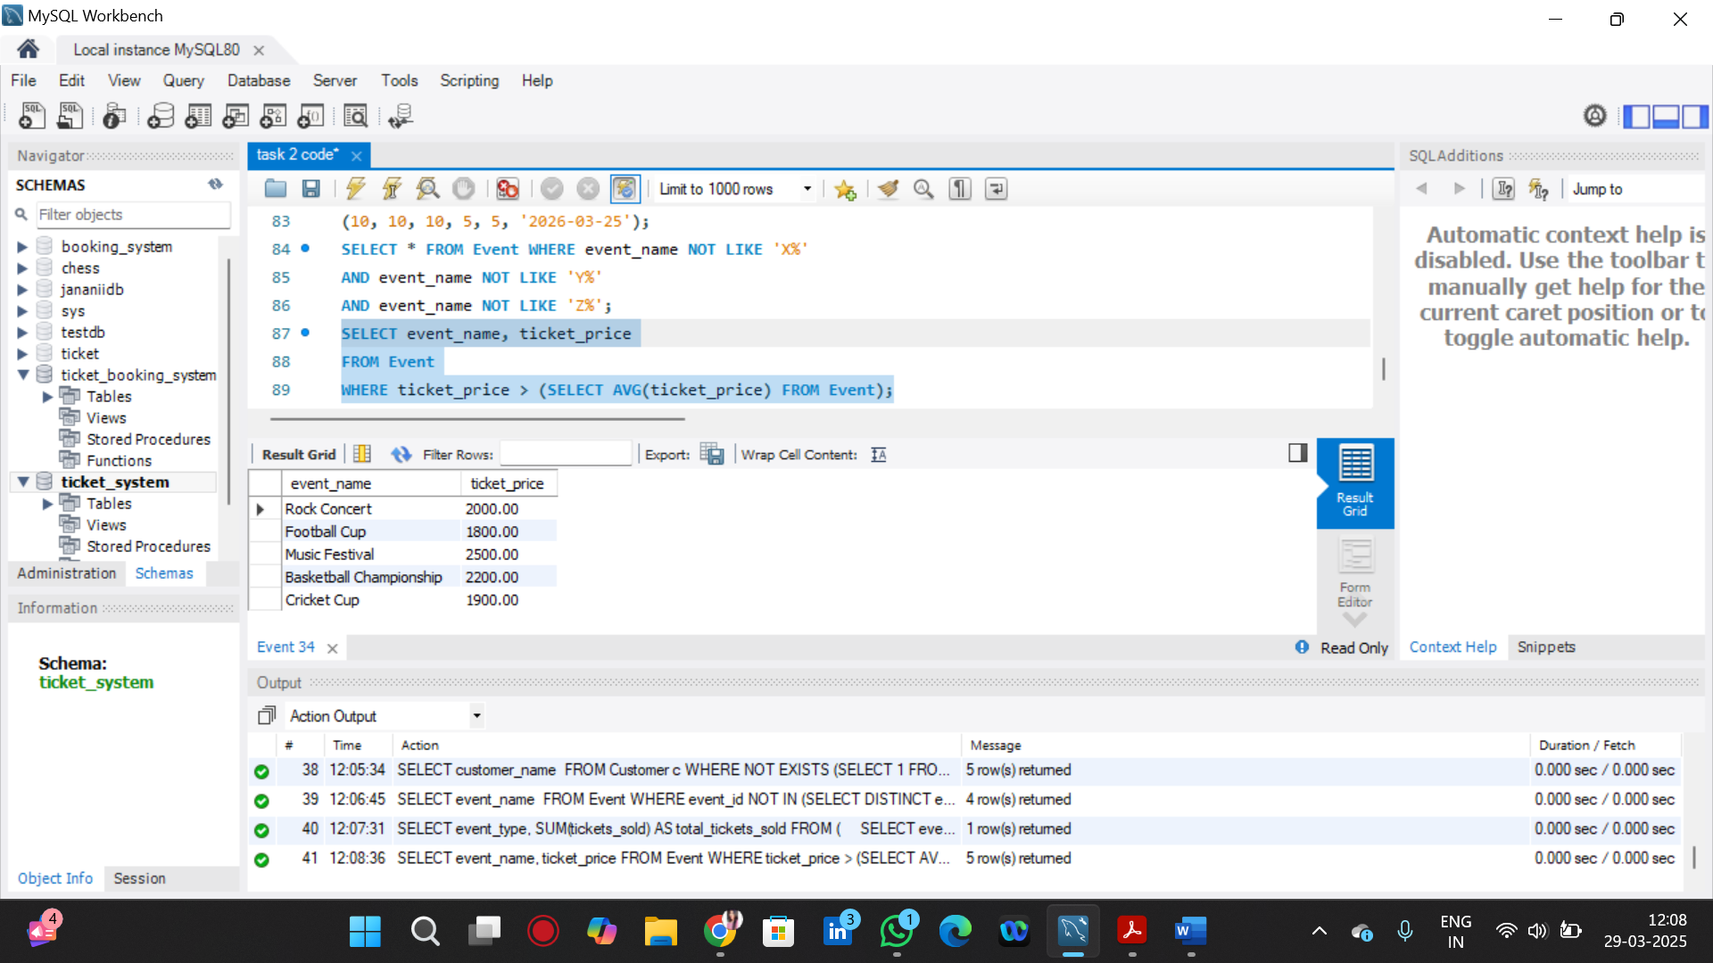

8. Calculate the Total Revenue Generated by Events for Each User Using a Correlated Subquery.

SELECT customer_name,

(SELECT SUM(b.num_tickets * e.ticket_price)

FROM Booking b

JOIN Event e ON b.event_id = e.event_id

WHERE b.customer_id = c.customer_id) AS total_revenue

FROM Customer c;

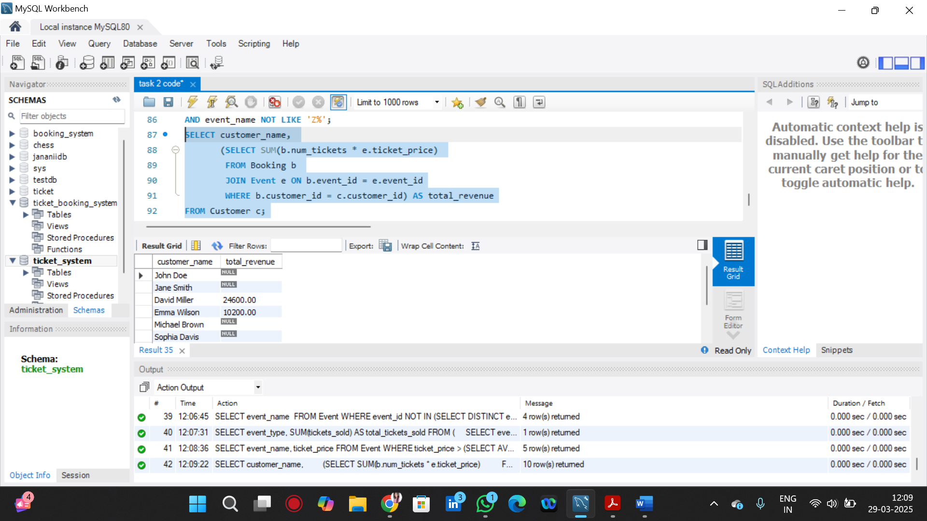

9. List Users Who Have Booked Tickets for Events in a Given Venue Using a Subquery in the WHERE Clause

SELECT * FROM Booking WHERE event_id IN (SELECT event_id FROM Event WHERE venue_id = 1);

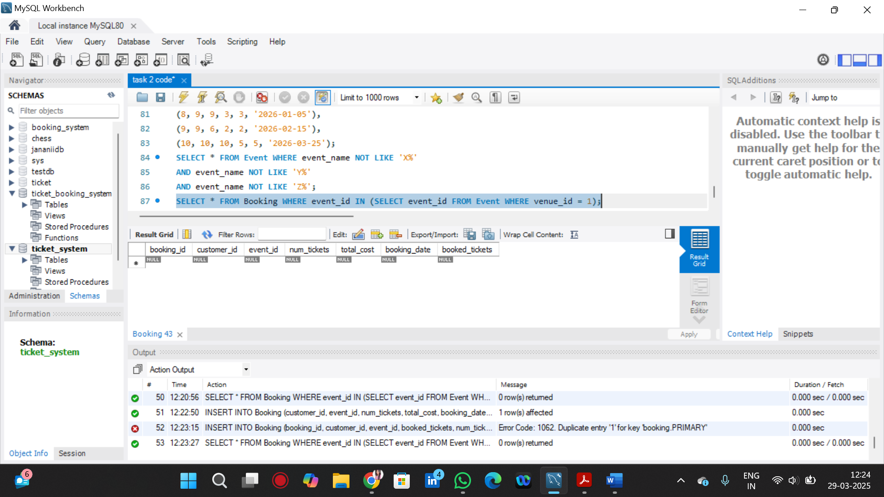

10. Calculate the Total Number of Tickets Sold for Each Event Category Using a Subquery with GROUP BY.

SELECT e.event_type,

SUM(b.num_tickets) AS total_tickets_sold

FROM Event e

LEFT JOIN Booking b ON e.event_id = b.event_id

GROUP BY e.event_type;

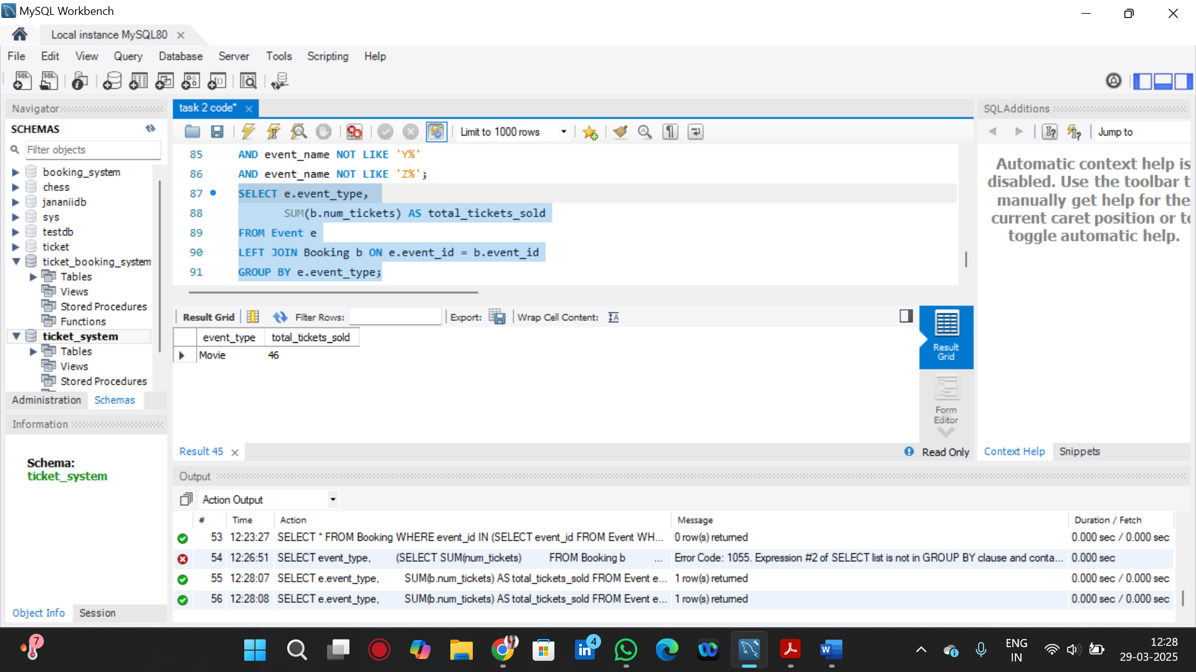

11. Find Users Who Have Booked Tickets for Events in each Month Using a Subquery with DATE_FORMAT.

SELECT DISTINCT customer_name,

(SELECT COUNT(*)

FROM Booking b

WHERE b.customer_id = c.customer_id

AND DATE_FORMAT(b.booking_date, '%Y-%m') = '2025-07') AS bookings_in_july

FROM Customer c;

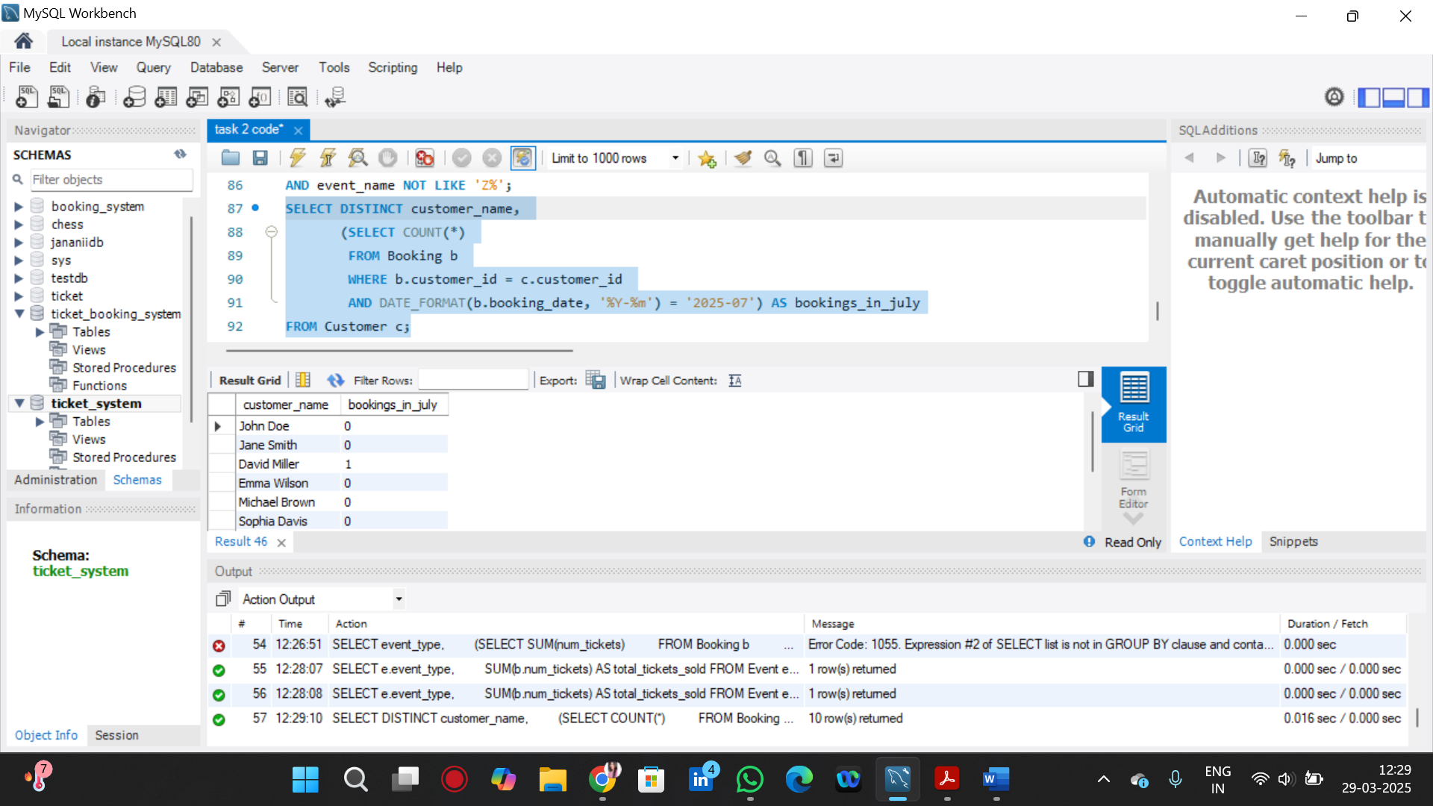

12. Calculate the Average Ticket Price for Events in Each Venue Using a Subquery

SELECT v.venue_name,

COALESCE(AVG(e.ticket_price), 0) AS avg_ticket_price

FROM Venue v

LEFT JOIN Event e ON v.venue_id = e.venue_id

GROUP BY v.venue_name;

